Mini Bot using Arduino and Android App

Prepared by
Rutvik Patel(16IT090)

Under the supervision of
Prof. Hemant Yadav

A Report Submitted to
Charotar University of Science and Technology
for Partial Fulfillment of the Requirements for the
Degree of Bachelor of Technology
in Information Technology
IT345 Software Group Project-II (5th sem)

Submitted at


DEPARTMENT OF INFORMATION TECHNOLOGY
Chandubhai S. Patel Institute of Technology
At: Changa, Dist: Anand – 388421
November 2018

CERTIFICATE

This is to certify that the report entitled “Mini Bot Using Arduino And Android App” is a bonafied work carried out by Mr. Rutvik J. Patel (16IT090) under the guidance and supervision of Prof. Hemant Yadav for the subject Software Group Project-II(IT345) of 5th Semester of Bachelor of Technology in Information Technology at Faculty of Technology & Engineering – CHARUSAT, Gujarat.

To the best of my knowledge and belief, this work embodies the work of candidate himself has duly been completed, and fulfills the requirement of the ordinance relating to the B.Tech. Degree of the University and is up to the standard in respect of content, presentation and language for being referred to the examiner.

Under supervision of,

Prof. Hemant Yadav
Assistant Professor
Dept. of Information Technology
CSPIT, Changa, Gujarat.

Prof. Parth Shah
Head & Associate Professor
Department of Information Technology
CSPIT, Changa, Gujarat.

Chandubhai S Patel Institute of Technology
At: Changa, Ta. Petlad, Dist. Anand, PIN: 388 421. Gujarat

ACKNOWLEDGEMENT

I have found this rare opportunity to evince a word of thanks to all those who played a key role in the successful completion of our project. I sincerely thank our Head of Department Parth Shah Sir for giving the chance as well as support for all the time being. And his able guidance and continuous encouragement made us work in all the challenges during project development. I express deep gratitude to Prof. Hemant Yadav, assistant professor and internal project guide from Faculty of Engineering, CHARUSAT for their valuable suggestions, help and moral support. Finally, most of all, I thank our family members for their unconditional love, encouragement and support to complete our project work. I also thank to all those who could not find a separate name but have helped directly and indirectly.

Rutvik Patel(16IT090)

Abstract

In this project I have a made a robot which is controlled by any android device by designing an android application using Arduino Uno. I have written the Arduino library’s from which robot moves left, right, forward, backward using the android application.

The application having five major buttons left, right, forward, backward and stop.

INDEX

Serial number | Chapter | Page number
1 | Project definition……………………………… | 6
2 | Objective…………………………………….... | 9
3 | Software and hardware requirement………….. | 10
4 | Major functionality…………………………… | 11
5 | Screenshots of the project output……………... | 12
6 | Limitations……………………………………. | 13
7 | Outcome………………………………………. | 14
8 | Future enhancement…………………………... | 15
9 | References…………………………………….. | 16

Chapter 1: Project Definition

- In this project to establish communication between Arduino and Android I have use the Bluetooth module HC-05. It sends data over short distances.
- Android devices also give us a wide platform to work and it can be easily integrate with any other device.
- Here I have also use the two DC motors and L293d motor driver IC to control the motor accordingly to its application.
- It works on only +5v dc supply to apply power to the motor there is input port of +12v.
- Here the motor works on +9v dc supply.

Block diagram

Android Device
HC-05
Arduino Uno
L293d

Motor1

Motor 2

Explanation

- Here the android device sends the data from the Bluetooth to the HC-05 and then the data is transmitted to the Arduino then accordingly to the information Arduino send data to l293D accordingly it moves the robot left, right, forward, backward and stop.

Circuit Diagram

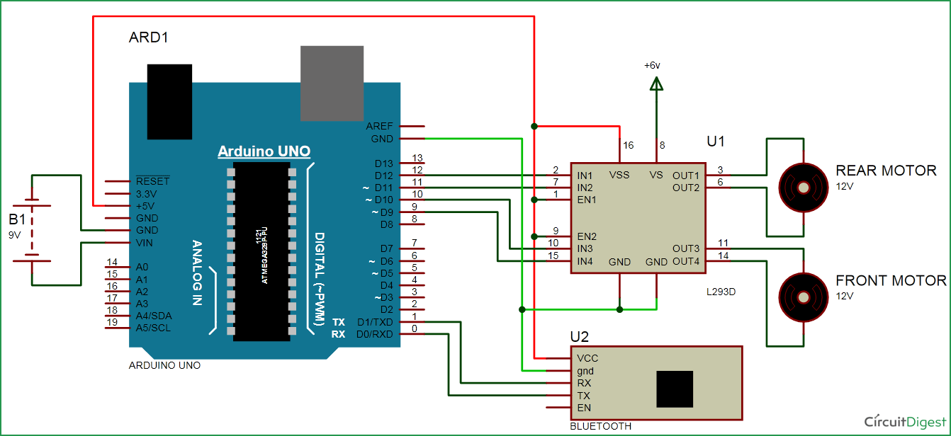

Explanation

Here the Arduino is connected with the L293d, HC-05, and the L293d is connected with the motors. L293d is connected with the 9,10,11,12 number of pins with the Arduino and HC-05 is connected with the 0,1 pins of Arduino which are RX, TX of the Arduino. The HC-05 RX is connected with the TX of the Arduino and the TX of Bluetooth module is connected with the RX of the Arduino. The output of the L293d is connected with the motors. As application sends the data from the Bluetooth to the HC-05 it receives the data and send to the Arduino and the Motor works.

Chapter 2: Objectives

- User just have to give commands to the bot through an android application.

- Android Application’s command performs by receiving and transmitting signal from the Bluetooth Module (HC05) which is connected with Arduino and Motor driver (L293D).

Chapter 3: Software and Hardware Requirements

- Software Requirements: Arduino IDE, Android Application

- Hardware Requirements: Arduino, L293D Motor Driver, DC motors, HC05 Bluetooth module, Batteries (9 volts), Wires.

Chapter 4: Major Functionality

- This bot has the Bluetooth module(HC05) to catch the commands from the android application so basically it is completely wireless path between bot and remote(App).
- It can be used in many field likewise in the military purposes.
- It can be used as a toy car.
- We can add one mini camera on it and can check robbery type process and record it.
- We can also pass some message with the help of that.

Chapter 5: Screenshots of project output

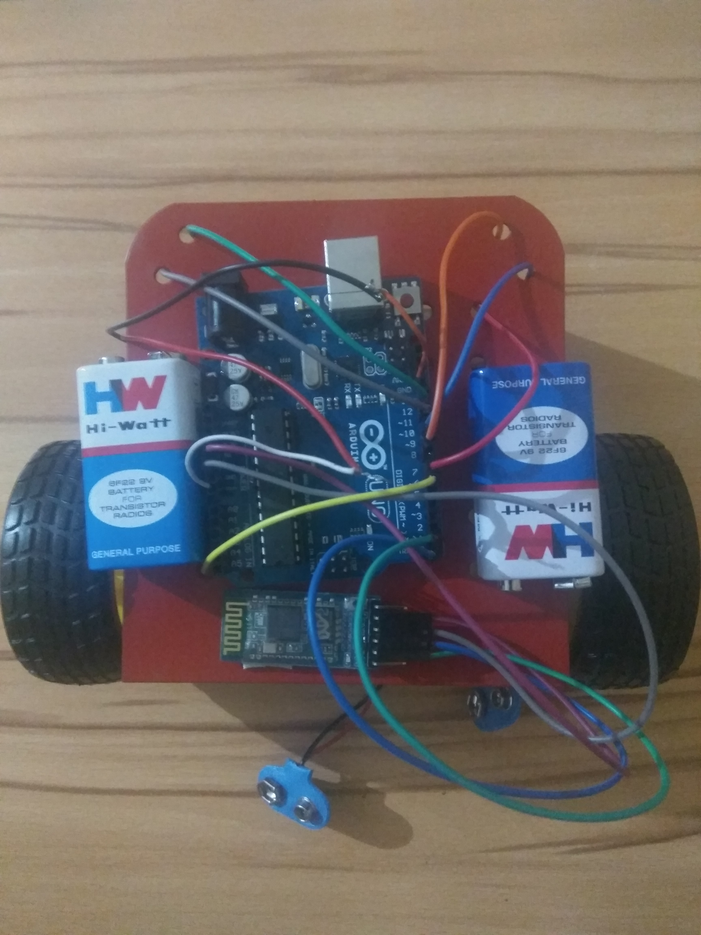

Chapter 6: Limitations of project

- If in between moving bot any dc battery goes down (Discharge) then bot will be stop because bot can not gain power from that battery.
- There can be a surface problem.
- There can be a connection problem.

Chapter 7: Outcome

- In this project I have learned how interface Arduino with the Bluetooth module.
- I have also learned how to deal with some embedded components.
- I have learned some more application of the Arduino.
- More importantly I have made this project just gain some more knowledge in the field of embedded systems.

Chapter 8: Future Enhancement

- By using more efficient motor-driver which can handle more voltage from battery, we can extend the lifetime of the bot
- By putting a mini camera in front of the bot we can record or see some activities.
- We can add an ultrasonic sensor to detect any obstacle within 10 cm.
- Ultrasonic sensor is to prevent the accident, if any obstacle comes within 10 cm it will stops the motor, and the bot will stop moving.

Chapter 9: References

1) http://www.manelsoft.com/projects/arduino_rc_car.aspx
2) https://circuitdigest.com/microcontroller-projects/bluetooth-controlled-robot-car-using-arduino
3)http://www.academia.edu/25301741/ARDUINO_BASED_WIRELESS_CONTROLLED_REMOTE_CONTROL_CAR
4) https://www.instructables.com/id/Remote-Controlled-Arduino-Car/
5) https://youtu.be/kewza7RyKMQ

